STATE OF HAWAII

NATURAL ENERGY LABORATORY OF HAWAII AUTHORITY
NELHA Security Services
HIePRO Solicitation: 26001725
eIFB-26-03-NELHA

1. INTRODUCTION PAGE NO.
1.01 TERMS AND ACRONYMS USED THROUGHOUT THE SOLICITATION 3
1.02 INTRODUCTION 3

2. SPECIFICATIONS
2.01 SCOPE 5
2.02 SPECIFICATIONS 12
2.03 OFFICER IN CHARGE 13
2.04 TERM OF CONTRACT 13
2.05 COMPENSATION 13
2.06 QUALITY CONTROL 13
2.07 WORK CONDUCT 14
2.08 BONDS 15

3. SPECIAL PROVISIONS
3.01 BID PREPARATION 16
3.02 SUBMISSION OF BID 16
3.03 BIDDER QUALIFICATIONS 16
3.04 CERTIFICATION OF INDEPENDENT COST DETERMINATION 17
3.05 DISQUALIFICATIONS OF BIDS 17
3.06 AWARD OF CONTRACT 17
3.07 EXECUTION OF CONTRACT 18
3.08 NOTICE TO PROCEED 18
3.09 BID AS PART OF THE CONTRACT 18
3.10 RESPONSIBILITY OF BIDDERS 18
3.11 CAMPAIGN CONTRIBUTIONS 19
3.12 PAYMENT 19
3.13 RIGHTS AND REMEDIES FOR DEFAULT 19
3.14 SPECIAL CONDITIONS 20
3.15 BACKGROUND CHECK 20
3.16 STATUTORY REQUIREMENTS OF SECTION 103-55, HRS 20
3.17 PAYROLL AFFIDAVITS 21
3.18 LIABILTY INSURANCE 21
3.19 PRICE ADJUSTMENT DUE TO WAGE INCREASE TO STATE EMPLOYEES 22

4. ATTACHMENTS
OFFER FORM OF-1 Attachment 1
OFFER FORM OF-2 Attachment 2
CERTIFICATE FOR FINAL PAYMENT (SPO FORM-22) Attachment 3
GENERAL CONDITIONS Attachment 4
SECURITY SERVICES PATROL MAP Attachment 5
POSITION DESCRIPTION FOR SECURITY OFFICER Attachment 6
WAGE CERTIFICATE Attachment 7
HOLIDAY SCHEDULE Attachment 8
SECTION ONE: INTRODUCTION

1.01 TERMS AND ACRONYMS USED THROUGHOUT THE SOLICITATION
Contact Person | = | Departmental Contracts Specialist, as identified in this Electronic Invitation for Bid
Contractor | = | The Bidder awarded a contract under this Electronic Invitation for Bid
CPO | = | Chief Procurement Officer
State | = | State of Hawaii, including each department and political subdivision
DBEDT | = | Department of Business, Economic Development, and Tourism
Procurement Officer | = | The Natural Energy Laboratory of Hawaii Authority, Executive Director
HAR | = | Hawaii Administrative Rules
HRS | = | Hawaii Revised Statutes
eIFB | = | Electronic Invitation for Bid
GC | = | General Conditions, AG-008
GET | = | General Excise Tax
Bidder | = | Any individual, partnership, firm, corporation, joint venture, or representative or agent, submitting an offer in response to this solicitation.
NELHA | = | Natural Energy Laboratory of Hawaii Authority
HIePRO | = | Hawaii Electronic Procurement System

1.02. INTRODUCTION
Pursuant to the Hawaii Public Procurement Code, Chapter 103D, HRS, the State of Hawaii, Natural Energy Laboratory of Hawaii Authority (NELHA) is soliciting bids for Security services at NELHA.
The Natural Energy Laboratory of Hawaii Authority (NELHA) was established to manage and operate a facility for the research and development of aquaculture and ocean related technology and business enterprises. The work to be performed under this contract shall consist of providing security services for the State of Hawaii, Natural Energy Laboratory of Hawaii authority (NELHA) at Keahole Point, near Kailua-Kona, Hawaii. The services provided by the CONTRACTOR shall include all labor, materials, equipment, and other incidentals necessary to provide these security services. Security Services will be needed at NELHA starting on the date indicated by the Notice to Proceed. Services shall commence as soon as a contract can be executed.
All prospective Bidders are invited to attend a non-mandatory pre-proposal conference to be held at the Natural Energy Laboratory of Hawaii Authority – Hale Iako Building, 73-970 Makako Bay Dr., Kailua-Kona, Hawaii on Tuesday, February 17, 2026, at 10:00 am. The meeting is not mandatory, but we strongly encourage interested bidders to attend.

Prospective Bidders are also invited to attend virtually via the Zoom link for this pre-proposal conference as shown below:

NELHA is inviting you to a scheduled Zoom meeting.

Topic: Security Services: Pre-Proposal Conference
Time: Feb 19, 2026, 10:00 AM Hawaii
Join Zoom Meeting
https://us06web.zoom.us/j/88014877636?pwd=Zh2IJSjH1GXRPTlGujQAxW1Z3wFHaA.1

Meeting ID: 880 1487 7636
Passcode: 731591

One tap mobile
+13462487799,,88014877636# US (Houston)
+16694449171,,88014877636# US

SECTION TWO: SPECIFICATIONS
The CONTRACTOR shall perform and provide, in a satisfactory and proper manner as determined by the STATE, all goods and services set forth in the competitive bid number HIePRO 26001725 / eIFB-26-03-NELHA, incorporated herein by reference, and the CONTRACTOR’S accepted bid, attached hereto and incorporated herein.
- WORK TO BE PERFORMED
The work to be performed under this contract shall consist of providing security services for the State of Hawaii (STATE), Natural Energy Laboratory of Hawaii authority (NELHA) at Keahole Point, near Kailua-Kona, Hawaii. The services provided by the CONTRACTOR shall include all labor, materials, equipment, and other incidentals necessary to accomplish the following tasks:
- CONTRACTOR shall ensure that all work described herein, to include each part of said work, shall be complete in every respect and coordinated with any follow-up on phase or sequence of work.
- CONTRACTOR shall provide one uniformed security officer per shift to provide daily foot and vehicle patrols of the NELHA facility according to the following schedule:
- Monday – Saturday Morning
Swing Shift: 1800 – 2200 hrs. (6:00 PM – 10:00 PM)
Graveyard Shift: 2200 – 0600 hrs. (10:00 PM – 6:00 AM)
- Saturdays, Sundays, and State & Federal Holidays
Day Shift: 0600 – 1400 hrs. (6:00 AM – 2:00 PM)
Swing Shift 1400 – 2200 hrs. (2:00 PM – 10:00 PM)
Graveyard Shift 2200 – 0600 hrs. (10:00 PM – 6:00 AM)
- Security services shall be provided for the main HOST Park Keahole Point Makai Research Campus areas and buildings, for four HOST Park (4) pump stations, for the HOST Park Mauka Research Campus and building, for the public beach park, for the 2.2-mile common public areas along Makako Bay Drive, and patrols along the 0.85-mile common public areas along Kahilihili St. (as illustrated in Attachment 5). Services shall also include opening and closing up to eleven vehicle gates.
- During each foot and vehicle patrol, the CONTRACTOR shall:
- Open and/or Close Gates.
    - Gate A: “Highway Guard Station Gate” located on Makako Bay Drive and the Queen Kaahumanu Hwy. This gate is closed only during special circumstances at a time designated by NELHA.
    - Gate B: “Main Entry Gate” located on Makako Bay Drive west (makai) of the intersection of Makako Bay Drive and Kahilihili Street. The CONTRACTOR will be required to close and lock this gate at 2000 hrs. and reopen the gate a 0545 hrs. The “Main Entry Gate” is the location where HOST Park Clients have access to (monthly changing combo lock). Also there are periods of shift workers passing through the gate. These shift change time periods are around 2200 hrs. and 0545 hrs. Vigilance is needed to ensure the gate is closed after the shifts workers pass through the gate.
    - Gate C: “South Gate” is located at NELHA’s southern boundary on an unpaved road. This gate must be opened daily at 0530 hrs. and closed daily at 1900 hrs.
    - Gate D: “RC Makai Gate” is located at the NELHA Keahole Point Makai Research Campus (RC). This gate is to be closed at 1800 hrs., Monday through Friday. The Makai RC gate is to be kept closed and locked at all times (24/7) on Saturday, Sunday, and holidays. Clients and NELHA staff who work within the Makai RC have been issued keys to access the compound as needed.
    - Gate E: “RC Mauka Gate” is the three-acre NELHA Mauka Research Campus (RC) located at 73-188 Makako Bay Drive. This gate is to be closed at 1830 hrs., Monday through Friday, and to be kept closed and locked at all times (24/7) on Saturday, Sunday, and holidays. Clients and NELHA staff who work within the building and three-acre campus have been issued keys to access the compound as needed.
    - Gate F: “Unualoha South Gate” is located at the intersection of Makako Bay Drive and Unualoha Bay Drive. This gate is to be closed at 1800 hrs., Monday through Friday. The Unualoha South Gate is to be kept closed and locked at all times (24/7) on Saturday, Sunday, and holidays. Clients who work within the Farm Compound have been issued keys to access their facilities as needed.
    - Gate G: “Unualoha North Gate” is located north of the Cyanotech Innovation Center and will remain closed at all times.
    - Gate H: “Beach Park Gate” is located at the 90-degree bend in Makako Bay Drive at the beach park. This gate is closed at 1900 hrs. and reopened at 0530 hrs.
    - Gate I: “Keahole Point Gate” is currently under planning and construction. This gate once installed will be closed at 1930 hrs. and reopened at 0515 hrs.
    - Gate J: “Ho’ona Historical Preserve Gate” is located at the end of the Ha’uke’uke Way at Keahole Point. The gate remains closed at all times. Vehicle access to this area is only allowed through special Acknowledgement of Presence and Practice permit issued by the NELHA Executive Director. General public foot traffic is allowed in the area between 0545 hrs. to 1930 hrs.
    - Gate K: “Jeep Road (Beach Park Trail) Gate” is located at Keahole Point off of Ha’uke’uke Way close to the Symbrosia and Sea Salt Farm Facility. The gate remains closed to all vehicle traffic at all times to prevent damage to sensitive environmental and cultural areas. General public foot traffic is allowed in the area between 0545 hrs. to 1930 hrs.
It should be noted that all employees who work on NELHA property are issued a parking pass to be displayed on their rear-view mirror. The parking pass is used for identification purposes only. NELHA and tenant employees have been issued a uniquely numbered NELHA “AUTHORIZED” parking pass. The number on each parking pass designates the specific person that pass has been issued to.
- Conduct conspicuous patrols by foot and/or vehicle a minimum of every two hours along the Makako Bay Drive and Kahilihili Street to watch for suspicious and unusual conditions and to enforce posted public access and park regulations. Contractor must provide a method (bar code scan, wand, etc.) to verify that these patrols have been implemented on schedule and at the locations specified.
PARK REGULATION:
The following activities are prohibited.
- Alcohol Beverages
- Camping
- Vehicles on the Beach
- ATV and Off-Roading
- Littering
- Open Fires
- Dumping of Coals
- Drones and Kite Flying
- Ensure that security personnel shall use tact and good judgment to prevent or minimize disorders, quell disturbances, and maintain law and order.
- Ensure that security personnel shall prepare and submit Incident Reports to NELHA, covering in detail all disturbances, incidents and violations that were observed or reported during each shift. Such report shall contain all pertinent facts available, to include, but not limited to the names and description of all vehicles, license plate identification, and persons involved. These Incident Reports shall be submitted in electronic or paper media format. Incident reports shall also include recommendations to improve security measures whenever appropriate.
- Upon the completion of each shift, CONTRACTOR shall assure that security officers complete a Security Report/Log of activities encountered and accomplished during the shift and submit a copy of this report/log to NELHA.
- Check all doors for Hale Iako, Hale Wai Ono, NELHA Operations, Power Center, White Tent, and Keena Hana buildings within the Keahole Point Research Campus to assure that they are locked and secure.
- Open the main entrance doors to the Hale Iako business center building at 0515 hrs. and close these same doors at 1800 hrs., Monday through Friday. The doors to be unlocked and locked for this building during the prescribed days and time mentioned shall be the three sets of double glass doors downstairs, the upstairs single parking lot door (facing northeast) and the upstairs single lanai door (facing southwest). The Hale Iako business center building shall remain locked on Saturday, Sunday, and Holidays. Clients who work within the Hale Iako business center building have been issued keys to access their offices as needed.
- Check the NELHA pump stations during routine patrols every two hours to monitor any abnormal activities or concerns with the NELHA seawater system. Each pump station is equipped with a separate alarm system (flashing yellow light and/or horn). When these alarm systems are triggered or unusual water or sound activity is noticed, the emergency NELHA cell phone number is to be called immediately. That number is (808) 217-0330.
- Check the Mauka Research Campus gate “RC Makai Gate” and all main building doors during routine patrols every two hours to assure that they are locked and secure.
- Notify NELHA emergency response staff on call (808) 217-0330, and/or the County of Hawaii police immediately of suspicious, unsafe and/or emergency conditions.
- Notify members of the public on site that the NELHA gates at the highway entrance and southern boundary will be closing and assure that all members of the public have left the property by the time all of the gates are closed at 2000 hrs. This action will involve moving the public and unauthorized personnel and vehicles out of the NELHA property as scheduled on a nightly basis.
- Security Personnel shall park at the main NELHA entry gate between 2130 hrs. and 2230 hrs. to monitor a Cyanotech Corporation employee shift change. The main outgoing gate shall be left open during this one-hour period to allow the Cyanotech employees to leave and arrive to work without having to stop to open or close this gate. All Cyanotech employees arriving to work shall be displaying a uniquely numbered NELHA AUTHORIZED parking pass on their review mirror to properly identify themselves. No one shall be allowed to enter the NELHA facility during this one-hour period or any other time when the main gate is open after 2000 hrs. unless they are displaying one of these colored parking passes. The main entry gate shall be closed and relocked at 2230 hrs.
5. CONTRACTOR shall ensure that the security officers assigned to the NELHA facility are thoroughly familiar with policies and procedures prior to reporting to work. CONTRACTOR shall ensure that they are in compliance with Act 208, SLH 2010; which states that all individual guards, and all agents, operatives, and assistants employed by a guard agency, private business entity, or government agency who act in a guard capacity shall be registered with the Board of Private Detectives and Guards. All employees shall be properly registered with the State of Hawaii DCCA Licensing Board. Proof of a Guard Registration Card shall be supplied for all proposed guards to service NELHA. Security officers assigned to work at NELHA must keep their guard cards current. CONTRACTORS supervisor shall supply evidence to NELHA in the form of current guard licenses before beginning work.
6. CONTRACTOR shall select officers that have displayed courteous and cooperative behavior in previous work. Said officers shall at all times maintain a professional, courteous, and cooperative relationship with NELHA staff, business clients, visitors, and all members of the public. These officers shall preserve order firmly without being overly aggressive or abusive. CONTRACTOR shall with the assistance of the NELHA staff, train the officers in interpreting and enforcing the rules and regulations relating to security of NELHA and its facilities.
7. CONTRACTOR shall ensure that all security officers are uniformed and shall maintain a neat and well-groomed appearance at all times. Uniforms should be of a light and comfortable fitting material as security officers shall be required to constantly move about the NELHA premises. NELHA does not condone or approve of family members or friends accompanying the security officers in the course of performing their duties.
8. CONTRACTOR shall provide its security officers with a company-provided cell phone to rotate between each officer per shift. The cell phone must be turned on, properly charged, and carried by the on-duty officer at all times while on duty. The phone number of this cell phone shall be provided to NELHA and NELHA shall be notified of any changes that occur to the function or replacement of this phone. The security officer’s supervisor shall be provided a company cell phone. The phone number of this cell phone shall be provided to NELHA and NELHA shall be notified of any changes that occur to the function or replacement of this phone.
10. CONTRACTOR is to supply a company-owned vehicle for the road patrols for each shift. This vehicle shall display the name of the security company on the driver and passenger sides of the vehicle. Ideally, this vehicle shall also have a flashing amber light on the roof that can controlled from within the cab. Maintenance and repair of this vehicle shall be the responsibility of the CONTRACTOR and shall be performed in a timely manner. Fueling and maintenance of this vehicle shall be at the CONTRACTOR’S expense and shall be done so on the CONTRACTOR’S own time (i.e. not on NELHA’s time). This vehicle is to remain on site during shift hours. Use of security officer owned vehicles are not allowed.
11. CONTRACTOR shall ensure that assigned security officers shall promptly and satisfactorily respond to security calls made by the NELHA Operations Manager or Operations Supervisor with regard to workstations, duties, assignments, and any and all work described herein.
12. CONTRACTOR must provide security officers with a method (bar code scan, wand, time clock, etc.) of verifying that they have arrived to work on time and as scheduled. This verification can be the same as the method for verifying road and foot patrols and shall be available for NELHA’s use for the purpose of cross-checking security officer’s schedules. A monthly schedule broken down on a weekly basis of the officers assigned to work at NELHA shall be posted on the bulletin board in the main security officer station at the Research Campus.
13. CONTRACTOR shall, at the request of the NELHA, remove and replace any security officer that NELHA deems to have acted inappropriately or found unable to perform the duties and responsibilities as defined in the general and detailed specifications herein and as defined by NELHA’s policies and procedures.
14. Maintenance and repair of all contractor-supplied equipment shall be the responsibility of the CONTRACTOR, shall be performed in a timely manner, shall be at the CONTRACTOR’S expense and shall be done on the CONTRACTOR’S own time.
15. The STATE shall have the authority to reduce or increase the total number of hours by providing a written notice to the CONTRACTOR a minimum of sixty (60) calendar days prior to the reduction or increase to the total number of hours.
16. CONTRACTOR shall be responsible for any repairs for NELHA/STATE property or equipment damaged by CONTRACTOR'S employees.
18. ALTERNATE #1: CONTRACTOR shall, upon request by the NELHA, provide additional security services during or after working hours at the same bid price per officer per hour specified in the Agreement. However, if the regularly assigned security officers are requested by STATE, the same shall be subject to overtime regulations by the State of Hawaii, Department of Labor. Additional security services shall be authorized by way of issuance of a purchase order by NELHA/STATE and shall be funded outside of the compensation encumbered under the Agreement and paid to CONTRACTOR in accordance with that Agreement. This does not guarantee the CONTRACTOR shall be selected for any security services provided on the premises outside of working hours. This work may require being able to respond to Civil Defense emergencies to close the NELHA Beach Park and shore within one to two hours of notification.
B. CONTRACTOR shall provide:
- A uniformed security officer to perform the duties listed above on the prescribed days and during the prescribed hours.
- A company furnished vehicle to conduct prescribed road and facility patrols for each scheduled shift. A four-wheel drive vehicle is preferable for off road patrols and gate closing functions.
- An electronic means of verifying that scheduled rounds, road patrols, and attendants work schedules are being performed as required. This verification method shall be a bar code scanner or similar device approved by NELHA. The information stored by this verification method shall be downloadable onto a personal computer and be able to interface to a printer.
- All labor, fuel, equipment, materials, supplies, supervision, and other incidentals necessary to satisfactorily perform the SPECIFICATIONS. Fueling of vehicle shall not occur during normally scheduled shifts and must be done on CONTRACTOR’S own time.
- A company cell phone to rotate between each scheduled shift. NELHA shall be given the phone number of this cell phone and notified of any changes that occur of the function or replacement of this phone.
- A company supervisor and 24-hour contact phone number (hard wire or cell phone) for NELHA to report discrepancies, emergencies, on-site situations and to verify that officers have reported to work on schedule.
C. NELHA shall provide:
  - Emergency response procedures and contact list.
  - Keys to the gates and premises.
  - NELHA Parking Pass Log
  - NELHA Policies, Rules, and Regulations

2.02 SPECIFICATIONS

A. QUALITY CONTROL AND INSPECTIONS

1. EXPECTED LEVEL OF SERVICE
The CONTRACTOR shall perform all services in a safe and efficient manner. The CONTRACTOR shall employ the best methods to provide services as specified herein. The CONTRACTOR shall further assure that the performance of work specified herein shall be in complete compliance with any applicable rules and regulations of all federal, state, and local governmental agencies. The CONTRACTOR shall be solely responsible for the satisfactory completion and quality of all work performed as determined by STATE.
- STATE’S INSPECTIONS
The Officer-In-Charge (OIC) or the OIC’s representative reserves the right to monitor CONTRACTOR's job performance at any time. The OIC may require
CONTRACTOR to accompany the OIC or the OIC’s designated representative in conducting evaluations.
- UNSCHEDULED DEPARTURE / MISSED SHIFTS
The CONTRACTOR is responsible for providing a security office for all shifts scheduled in the SPECIFICATIONS and for notifying the NELHA OIC immediately by calling (808) 747-4797 or as a backup by calling the NELHA Emergency Call Out phone at (808) 217-0330 for all missed or partially attended shifts due to security officer’s failure to report to work or unscheduled departures due to illness, injury, family emergency, etc.

EXAMINATION OF PREMISES
The CONTRACTOR shall contact the OIC and obtain permission before visiting the site for the purposes of this solicitation and only after a pre-bid conference has been completed.

CONDITIONS AT SITE
Every person bidding on this project is expected to visit the site and examine the conditions and satisfy themselves as to the character and amount of the work to be performed. No additional allowance will be granted because of the lack of knowledge of such conditions.

CONTRACTOR'S OPERATIONS
The CONTRACTOR must employ such methods and means of carrying out the SPECIFICATIONS and perform his work so as not to cause any interruption or interference to the facility's operations.

PROTECTION OF PROPERTY
The CONTRACTOR shall continually maintain adequate protection of all his work from damage and shall protect all property, including but not limited to buildings, equipment, furniture, grounds, vegetation, material, and utility systems located at and adjoining the job site. The CONTRACTOR shall repair, replace, or pay the expense of repairing damages resulting from his fault or negligence.

2.03 OFFICER-IN-CHARGE
For the purpose of this agreement, the NELHA Officer in Charge (OIC) shall be designated by the NELHA, Executive Director. All contact with NELHA shall be through the OIC or his/her designated Officer-in-Charge after contract has been executed.

2.04 TERM OF CONTRACT
The services by the CONTRACTOR described herein shall commence upon a written Notice to Proceed. The Contract shall be completed within thirteen (13) months of the Notice to Proceed, unless sooner terminated as hereinafter provided. This contract may be extended for a period not to exceed two (2) additional thirteen (13) month periods. Such an extension shall be only upon a mutual agreement in writing at least sixty (60) days prior to the expiration of the existing agreement and provided that funds are available and the contract price remains the same or lower than the initial price bid, except for any allowable increase related to increased wages of public employees performing like work.

2.05 COMPENSATION
- Award shall be made to the responsive and responsible Bidder submitting the lowest price.
- Payments shall be made only after satisfactory completion of each task or service as specified herein.
- If any work is not in full compliance with these specifications, the CONTRACTOR shall make all necessary corrections to the full satisfaction of the STATE and at no additional cost to the STATE. The CONTRACTOR shall perform corrective work within the period allowed by the Officer-In-Charge.

2.06. QUALITY CONTROL
- In the event the CONTRACTOR fails, refuses, or neglects to perform the services in accordance with the requirements of this eIFB, the STATE reserves the right to purchase, in the open market, a corresponding quantity of the services specified herein and to deduct from any monies due or that may thereafter become due to the CONTRACTOR, the difference between the prices named in the Contract and the actual cost thereof to the STATE.
In the event that any monies due to the CONTRACTOR are insufficient for said purpose, the CONTRACTOR shall pay the difference upon demand by the STATE. The STATE may also utilize all other remedies provided by law.
- The Bidder must assure and be responsible for the continuity of service activities in the event of staff illness, medical emergencies, vacancies, or other situations that result in program resources that are less than proposed and contracted for. The Bidder must not require or depend on STATE staff to provide service activities in the event that program resources are not available due to the above situations.
- When a disagreement arises between the Bidder and the STATE in regards to the performance of specific service requirements within the Contract specifications, the wishes of the STATE shall prevail. Failure on the part of the Bidder to comply shall be deemed cause for corrective action and subject to contractual remedies.
- The STATE reserves the right to reduce, amend, or expand the “Scope of Services.”
2.07. WORK CONDUCT

A. GENERAL
The CONTRACTOR shall perform all services in a safe and efficient manner. The CONTRACTOR shall employ the best methods to provide services as specified herein. The CONTRACTOR shall further assure that the performance of work specified herein shall be in complete compliance with any applicable rules and regulations of all federal, STATE and local governmental agencies. CONTRACTOR shall:
- Proceed with the work described herein upon notification by the STATE.
- Employ, insofar as is reasonably possible, such methods and means of carrying out its work so as not to cause any interruption or interference to the business being conducted at the NELHA operations.
- STATE reserves the right at any time to contract for or otherwise perform other or additional work within the contract zone limits of this Agreement. The CONTRACTOR of this project shall to the extent ordered by the STATE, conduct CONTRACTOR’s work so as not to interfere with or hinder the progress or completion of the work performed by other contractors.

B. WORK PERFORMANCE
The CONTRACTOR shall be solely responsible for the satisfactory completion and quality of all work performed as determined by STATE.
- The STATE of Hawaii shall hold the CONTRACTOR liable for all the acts of its employees.
- CONTRACTOR’S staff (i.e. security attendants) is to remain on site at all times during regular scheduled shifts and are not to leave the NELHA property for any reason.
- Should the CONTRACTOR discover any discrepancy in the specifications, the CONTRACTOR shall immediately notify the Officer-In-Charge before proceeding any further with the work, otherwise, CONTRACTOR will be held responsible for any cost involved in correction of work placed due to such discrepancy.
- Specifications are prepared in abbreviated form and include incomplete sentences. Omission of words or phrases such as “the CONTRACTOR shall”, “a”, “an”, and “the” are intentional. Omitted words and phrases shall be provided by inference to form complete sentences.

C. SAFE PERFORMANCE OF WORK
- The CONTRACTOR shall exercise care and shall provide all necessary protection to prevent injury and/or damage.
- The CONTRACTOR shall be required to protect the occupants and the general public from any unsafe conditions during the performance of services and/or as a result of the services.
- The Hawaii Occupational Safety and Health Law, Chapter 396, Hawaii Revised Statutes, effective May 16, 1972, as amended, is applicable and made a part of this solicitation as Exhibit C. The CONTRACTOR shall carefully read and strictly comply with its requirements.
2.08. BONDS
Bid, performance, and payment bonds are not required for this solicitation.

SECTION THREE: SPECIAL PROVISIONS

3.01. BID PREPARATION
- OFFER FORM OF-1 (Attachment 1). Bidders are requested to submit their Bids using their exact legal name, as registered with the State of Hawaii, Department of Commerce and Consumer Affairs, if applicable; and to indicate their exact legal name in the appropriate space on Offer Form OF-1. Failure to do so may delay proper execution of the Contract.
The signed Offer Form page OF-1 shall indicate Offeror’s intent to be bound.
- Tax Liability. Work to be performed under this eIFB is a business activity taxable under Chapter 237, HRS, and Chapter 238, HRS, where applicable. Bidders are advised that the gross receipts derived from this eIFB are subject to the general excise tax (GET) imposed by Chapter 237, HRS, and, where applicable, to tangible property imported into the State of Hawaii for resale, subject to the use tax imposed by Chapter 238, HRS.
- Hawaii General Excise Tax License. In accordance with Section 3.1 A of the General Terms and Conditions, Bidders shall submit their current Hawaii GET I.D. number in the space provided on the Offer Form OF-1.
- Bid Price. The Bid price shall include all labor, equipment, and transportation; all applicable taxes; and, any and all other costs to be incurred to provide services as specified herein.
- References. The Bidder shall list on the Offer Form OF-2, at least three (3) references for whom Bidder has performed similar services and who can, if necessary, attest to the Bidder’s performance. References not specific to the services described in this eIFB shall not be considered acceptable. It is expressly understood that the STATE reserves the right to seek additional references, and that unfavorable references may be grounds for the rejection of any bid.
- Offer Guaranty. A bid security deposit is not required for this bid.
- Notice of Intent to Bid. Prospective bidders are not required to submit any notice of intent to bid.

3.02. SUBMISSION OF BID
Bids shall be received electronically through the HIePro. Bids received outside of the HIePRO shall not be considered for award.

3.03. BIDDER QUALIFICATION
In addition to meeting the legal and other requirements of this eIFB, Bidders must meet these Bidder qualification requirements at the time of bidding.
- All Bidders shall have local office/representative(s) in-place in Hawaii, at the time of bid opening. All Bidders shall list contact information for its local office and/or responsible individuals who can be contacted by the STATE on matters concerning this eIFB on the Offer Form OF-1.
- This eIFB is issued under the provisions of Chapter 103D, HRS, and Subchapter 3-122, HAR. All Bidders are charged with presumptive knowledge of all requirements of the cited authorities. Submission of a valid, executed bid by any Bidder shall constitute admission of such knowledge on the part of such Bidder.
- Bidder must have a valid guard service license registered with the Hawaii State Department of Commerce and Consumer Affairs at the time of bid submittal. The guard services license number shall be noted on Offer Form, Page OF-2.
- Bidder must have been in the security guard business for a minimum of two (2) consecutive years.

3.04. CERTIFICATION OF INDEPENDENT COST DETERMINATION
By submission of a Bid in response to this eIFB, the Bidder certifies as follows:
- The costs in this eIFB have been arrived at independently, without consultation, communication, or agreement with any other Bidder, as to any matter relating to such costs for the purpose of restricting competition.
- Unless competition otherwise required by law, the costs which have been quoted in this eIFB have not been knowingly disclosed by the Bidder prior to award, directly or indirectly, to any other Bidder or competitor prior to the award of the contract.
- No other attempt has been made or will be made by the Bidder to indicate any other person or firm to submit or not to submit a Bid for the purpose of restricting competition.

3.05. DISQUALIFICATION OF BIDS
The STATE reserves the right to consider as acceptable only those bids submitted in accordance with all requirements set forth in this eIFB and which demonstrate an understanding of the scope of services. Any bid offering any other set of terms and conditions contradictory to those included in this eIFB may be disqualified without further notice.
Each bid shall be submitted in the format prescribed in this eIFB and all portions shall be addressed.

3.06. AWARD OF CONTRACT
Award, if made, shall be made to the responsive, responsible Bidder submitting the lowest estimated total bid price.
Award shall be contingent on the availability of funds. The STATE reserves the right to cancel this eIFB and/or reject any and all bids, in whole or in part, when it is determined to be in the best interest of the State.

3.07. EXECUTION OF CONTRACT
No performance or payment bond shall be required for this Contract.
If an award is made, the STATE shall forward to the successful Bidder a formal contract to be signed by the Bidder and returned within ten (10) days or as may otherwise be allowed by the STATE. No work is to be undertaken by the Bidder prior to the official commencement date specified on a formal Notice to Proceed letter issued by the STATE upon execution of the Contract by both parties. The State of Hawaii is not liable for any work, contract, costs, expenses, loss of profits, or any damages whatsoever incurred by the Bidder prior to the official commencement date of the Contract.
The State of Hawaii is not liable for any work, contract, costs, expenses, loss of profits, or any damages whatsoever incurred by the company prior to the receipt of the notice to proceed.

3.08. NOTICE TO PROCEED
No work is to be undertaken by the CONTRACTOR prior to the official commencement date specified on the formal Notice to Proceed. The State is not liable for any work, contract, costs, expenses, loss of profits, or any damages whatsoever incurred by the CONTRACTOR prior to the work start date.

3.09. BID AS PART OF THE CONTRACT
This eIFB and the successful bid will be part of the Contract.
3.10. RESPONSIBILITY OF BIDDERS:
Bidders are advised that if awarded a contract under this solicitation, Bidders shall, upon award of the contract, furnish proof of compliance with the requirements of Sections 103D-310(c), HRS, as follows:
- Chapter 237, tax clearance
- Chapter 383, unemployment insurance
- Chapter 386, workers’ compensation
- Chapter 392, temporary disability insurance
- Chapter 393, prepaid health care
- Chapter 103C-310 (c), Certificate of Good Standing (COGS) for entities doing business in the State of Hawaii.
Hawaii Compliance Express.
A Bidder may collectively apply for these certificates through the Hawaii Compliance Express (HCE). The HCE allows businesses to register online through a simple wizard interface at http://vendors.ehawaii.gov/hce/splash/welcome.html to acquire a “Certificate of Vendor Compliance.” The HCE provides current compliance status as of the issuance date. The “Certificate of Vendor Compliance,” indicating that the vendor’s status is compliant with the requirements of HRS Section 103D-310(c), shall be accepted for both contracting purposes and final payment. Vendors that elect to use the new HCE services will be required to pay an annual fee of $12.00 to the Hawaii Information Consortium, LLC (HIC).
Pursuant to Procurement Circular No. 2011-02, CONTRACTOR must obtain proof of compliance through Hawaii Compliance Express previous to contract award for awards of $2,500 or more.

3.11. CAMPAIGN CONTRIBUTIONS BY STATE AND COUNTY CONTRACTORS
It has been determined that funds for a contract awarded under this eIFB have been appropriated by a legislative body.
Therefore, if a Bidder is awarded a contract in response to this eIFB, Bidder agrees to comply with Section 11-205.5, HRS, which states that campaign contributions are prohibited from a State or county government contractor during the term of the contract if the contractor is paid with funds appropriated by a legislative body.

3.12. PAYMENT
Section 103-10, HRS, provides that the STATE shall have 30 calendar days after receipt of an invoice or satisfactory performance of the services to make payment. For this reason, the STATE will reject any Bid submitted with a condition requiring payment within a shorter period. Further, the STATE will reject any Bid submitted with a condition requiring interest payments greater than that allowed by Section 103-10, HRS, as amended.
The STATE will not recognize any requirement established by the CONTRACTOR and communicated to the STATE after award of the Contract, which requires payment within a shorter period, or interested payment not in conformance with Section 103-10, HRS.

3.13. RIGHTS AND REMEDIES FOR DEFAULT
In the event the CONTRACTOR fails, refuses or neglects to perform the services in accordance with the requirements of this eIFB and Attachment 4, “General Conditions,” as specified herein, the STATE reserves the right to purchase, in the open market, a corresponding quantity of the goods specified herein and to deduct from any monies due or that may thereafter become due the CONTRACTOR, the difference between the price named in the Contract and the actual cost thereof to the STATE. In the event that any monies due to the CONTRACTOR are insufficient for said purpose, the CONTRACTOR shall pay the difference upon demand by the STATE. The STATE may also utilize all other remedies provided by law.

3.14. SPECIAL CONDITIONS
- All work and products developed shall comply with all applicable State, County, and Federal regulations, codes, and guidelines.
- The BIDDER must assure and be responsible for the continuity of service activities in the event of staff illness, medical emergencies, vacancies, or other situations that result in program resources that are less than proposed and contracted for. The Bidder must not require nor depend on the state agency’s staff to provide services activities in the event that program resources are not available due to the above situations.
- When a disagreement arises between the Bidder and the Department in regards to the performance of specific service requirements within contract specifications, the wishes of the Department shall prevail. Failure on the part of the Bidder to comply shall be deemed cause for corrective action and subject to contractual remedies.
- NELHA reserves the right to reduce, amend, or expand the “Scope of Services.”
- CONTRACTOR shall identify and submit the names of all employees and subcontractors that will be performing the work of this solicitation for prior STATE approval.
- Bid shall be valid for a minimum of one hundred twenty (120) calendar days.

3.15. BACKGROUND CHECK
All security officers assigned to this contract shall have the following clearances:
- Federal and State criminal clearance check. Documents of background checks shall be current and dated within thirty (30) days of submission to the NELHA. This information shall be submitted to the OIC within fourteen (14) days from receipt of the Notice of Award.
- Traffic abstract (no Driving Under the Influence of Alcohol or Drugs or careless driving conviction);
- No documented emotional or mental disorder;
- No criminal convictions which might deem the candidate unsuitable for employment.
CONTRACTOR, at no extra cost to NELHA, shall provide necessary evidence of compliance in this area. Upon review of a security officer’s background check, the NELHA reserves the right to request additional background information.

3.16. STATUTORY REQUIREMENTS OF SECTION 103-55, HRS
Bidder is advised that Section 103-55, HRS, provides that the services to be performed shall be performed by employees paid at wages not less than wages paid to public officers and employees for similar work. Bidder is further advised that in the event of an increase in wage rates to public employees performing similar work during the contract period, Contractor will be obliged to provide wages no less than those increased wages.
CONTRACTOR shall be further obliged to notify its employees performing work under this contract of the provisions of Section 103-55, HRS, and of the current wage rate for public employees performing similar work. Contractor may meet this obligation by posting a notice to this effect in the Contractor's place of business accessible to all employees, or Contractor may include such notice with each paycheck or pay envelope furnished to the employee.
To assist the bidder in determining whether the work his employees are to perform under this contract is similar to that performed by public employees, attached are class specifications for public employee positions that perform security attendant services. Effective July 1, 2025, the basic hourly wages paid to the State positions are as follows:
Class Hourly Rate
Security Officer I (Bargaining Unit 03, SR-13, Step C) $22.50/hr.
Attachment 6 – Position Descriptions for Security Officer I
Accordingly, Bidder should consider the aforementioned wage rates when preparing its quote. Bidder shall also submit a signed wage certificate (Attachment 7).

3.17. PAYROLL AFFIDAVITS
Upon the State’s request, Contractor will be required to submit quarterly payroll documentation to the SPO for all employees working under this contract. Documentation shall include employee time cards, payroll records, and copies of cancelled checks to verify that contractor’s employees are being paid State of Hawaii prevailing wages for hours worked under this contract.

3.18. LIABILITY INSURANCE
The Contractor shall maintain in full force and effect during the life of this contract, liability, and property damage insurance to protect the Contractor and his subcontractors, if any, from claims for damages for personal injury, accidental death and property damage which may arise from operations under this contract, whether such operations be by himself or by a subcontractor or anyone directly or indirectly employed by either of them. If any subcontractor is involved in the performance of the contract, the insurance policy or policies shall name the subcontractor as additional insured.
As an alternative to the Contractor providing insurance to cover operations performed by a subcontractor and naming the subcontractor as additional insured, Contractor may require subcontractor to provide its own insurance which meets the requirements herein. It is understood that a subcontractor's insurance policy or policies are in addition to the Contractor's own policy or policies.
The following minimum insurance coverage(s) and limit(s) shall be provided by the Contractor, including its subcontractor(s) where appropriate.

Coverage Limits
Commercial General Liability $1,000,000 per occurrence for
(occurrence form) bodily injury and property damage

And $2,000,000 in aggregate
Each insurance policy required by this contract, including a subcontractor's policy, shall contain the following clauses:
- "This insurance shall not be canceled, limited in scope of coverage or nonrenewed until after 30 days written notice has been given to the State of Hawaii, Department of Accounting and General Services, State
Procurement Office, P. O. Box 119, Honolulu, Hawaii 96810-0119."
- "The State of Hawaii is added as an additional insured as respects to operations performed for the State of Hawaii."
- "It is agreed that any insurance maintained by the State of Hawaii will apply in excess of, and not contribute with, insurance provided by this policy."
The minimum insurance required shall be in full compliance with the Hawaii Insurance Code throughout the entire term of the contract, including supplemental agreements.
Upon Contractor's execution of the contract, the Contractor agrees to deposit with the State of Hawaii certificate(s) of insurance necessary to satisfy the State that the insurance provisions of this contract have been complied with and to keep such insurance in effect and the certificate(s) therefore on deposit with the State during the entire term of this contract, including those of its subcontractor(s), where appropriate. Upon request by the State, Contractor shall be responsible for furnishing a copy of the policy or policies.
Failure of the Contractor to provide and keep in force such insurance shall be regarded as material default under this contract, entitling the State to exercise any or all of the remedies provided in this contract for a default of the Contractor.
The procuring of such required insurance shall not be construed to limit Contractor's liability hereunder nor to fulfill the indemnification provisions and requirements of this contract. Notwithstanding said policy or policies of insurance, Contractor shall be obliged for the full and total amount of any damage, injury, or loss caused by negligence or neglect connected with this contract.

3.19. PRICE ADJUSTMENT DUE TO WAGE INCREASE TO STATE EMPLOYEES
- Contract price adjustment shall be considered:
  - Only upon request by the Contractor accompanied by proof satisfactory to the State that its employees have been paid comparable wages to State employees; and
  - Only if there is a wage increase to public employees performing comparable work; and
  - Only for the contract period in which the price adjustment request is submitted
(current contract period only).

Example:
Original contract period:
Extension period No. 1:
Extension period No. 2:

April 3, 2026, thru April 2, 2027
April 3, 2027, thru April 2, 2028
April 3, 2028, thru April 2, 2029

- Price adjustment based on the actual dollar increase per hour per State employee shall be calculated as follows:
a. | Bid Price/Hr./Officer (A) | = (A) for example = $30.00/hr.
b. | Current Hourly Wage Range (B) | = (B) for example = $22.50/hr.
c. | New Hourly Wage Rate paid
 | to State Employees (C) | = (C) for example = $23.40/hr.
d. | Hourly Wage Increase to
 | State employees (D) | = (D) for example = $.90/hr.
e. | Adjusted Bid Price/Hr./Officer (E) | = (A) + (D) = (E), or  = $30.00/hr. + $0.90/hr. = $30.90/hr.
- In addition to the actual dollar amount of wage increase, Contractor may apply for the percentage (%) fringe benefits required by Statute. However, the resulting fringe benefit percentage shall only be applicable to the actual dollar amount of increase and the State shall only consider those benefits that are required by contract and are directly affected by the wage increase.
If request includes adjustment for wage related fringe benefits, Contractor must provide support documentation and an itemized percentage breakdown of the fringe benefits being paid.
The State has determined that the applicable fringe benefits for wage related price adjustments shall be limited to:
1) Federal Old Age Benefits
2) Worker Compensation
3) Temporary Disability Insurance
4) Unemployment Insurance
Based on past experience, it has been determined that the percentage increase be set at 16%. If Contractor is able to document that its percent for fringe is higher than 16%, the State will review and consider Contractor’s claim.
The following method of calculation shall be applied for the fringe benefits:
- 16% for Allowable Fringe Benefits
- $ Adjusted for Allowable Fringe Benefits (F) = (D) x (0.16) = F, or
$0.90 x 0.16 = $0.14
- Adjusted Bid Price/Hr./Officer + Fringe Benefits = (E) + (F), or
$30.90+$.14 = $31.04
4. After the contract modification for the increase is issued by the State, but before payment of an increase is made on the portion of the current contract period already performed, the Contractor shall show proof that its employees were given the retroactive wage increase.
SECTION FOUR ATTACHMENTS
ATTACHMENT 1:  ATTACHMENT 2:  ATTACHMENT 3:  ATTACHMENT 4:  ATTACHMENT 5:  ATTACHMENT 6:  ATTACHMENT 7:  ATTACHMENT 8: | OFFER FORM, OF-1  OFFER FORM, OF-2  CERTIFICATE FOR FINAL PAYMENT (SPO FORM-22)  GENERAL CONDITIONS  SECURITY SERVICES PATROL MAP  POSITION DESCRIPTION FOR SECURITY OFFICER I  WAGE CERTIFICATE  STATE HOLIDAY SCHEDULE

Attachment 1
OFFER FORM-OF-1
Natural Energy Laboratory of Hawaii Authority
73-4460 Queen Kaahumanu Hwy., #101 Kailua Kona, Hawaii 96740
Dear Ms. Jennifer Rasmussen:
The undersigned has carefully read and understands the terms and conditions specified in the Specifications and Special Provisions attached hereto, and in the General Conditions, AG-008, by reference made a part hereof and available upon request; and hereby submits the following offer to perform the work specified herein, all in accordance with the true intent and meaning thereof. The undersigned further understands and agrees that by submitting this offer, 1) he/she is declaring his/her offer is not in violation of Chapter 84, Hawaii Revised Statutes, concerning prohibited State contracts, and 2) he/she is certifying that the price(s) submitted was (were) independently arrived at without collusion.
The undersigned represents that it is: (Check √ one only)
 A Hawaii business incorporated or organized under the laws of the State of Hawaii; OR
 A Compliant Non-Hawaii business not incorporated or organized under the laws of the State of Hawaii, is or shall be registered at the State of Hawaii, Department of Commerce and Consumer Affairs Business Registration Division (DCCA-BREG) to do business in the State of Hawaii.
State of incorporation: _________________________
Offer is:
 Sole Proprietor  Partnership  *Corporation  Joint Venture  Other ___________________
Federal I.D. No.:_________________ Hawaii General Excise Tax License I.D. No.: _______________________
Payment address (other than street address below): _____________________________________________________
City, State, Zip Code: _____________________________________________________
Business address (street address): ____________________________________________________________________
City, State, Zip Code: ____________________________________________________________________
Respectfully submitted:
Date:______________________________ (x) _______________________________________________
Authorized (Original) Signature
Telephone No.:______________________
__________________________________________________
Fax No.: ___________________________ Name and Title (Please Type or Print)

E-mail Address:______________________ * _________________________________________________
Exact Legal Name of Company (Bidder)
*If Bidder is a “dba” or a “division” of a corporation, furnish the exact legal name of the corporation under which the awarded contract will be executed:

OFFER FORM OF-1 Revised 2/5/2026
Attachment 2
OFFER FORM-OF-2
REFERENCES
List the names and addresses of three (3) companies or government agencies for whom bidder has provided or is currently providing security attendant services:
Name Address Contact Person Phone
- ____________________________________________________________________________________
- ____________________________________________________________________________________
- ____________________________________________________________________________________
This is a Fixed Price Contract. Work to be accomplished is outlined in the specifications. All work shall be included in the total bid price below and no additional compensation shall be allowed. The Contract will be awarded to the lowest and/or best responsible bidder, or any and all bids may be rejected.
All work shall include all labor, material, equipment, supervision, procurement, material storage and transportation necessary to complete the project as specified herein.
All applicable sales taxes, State and/or Federal, City and County, and any other special taxes, patent rights, or royalties are included in the prices quoted in this bid.
Item No. | Description | Unit Price Per Hour | Estimated Total Cost
1 | Security Services | $________ | $____________
2 | Alternate #1 | $________

Offer___________________________________ Company Name
Guard Services License Number: _____________________________
OFFER FORM OF-2

Attachment 3
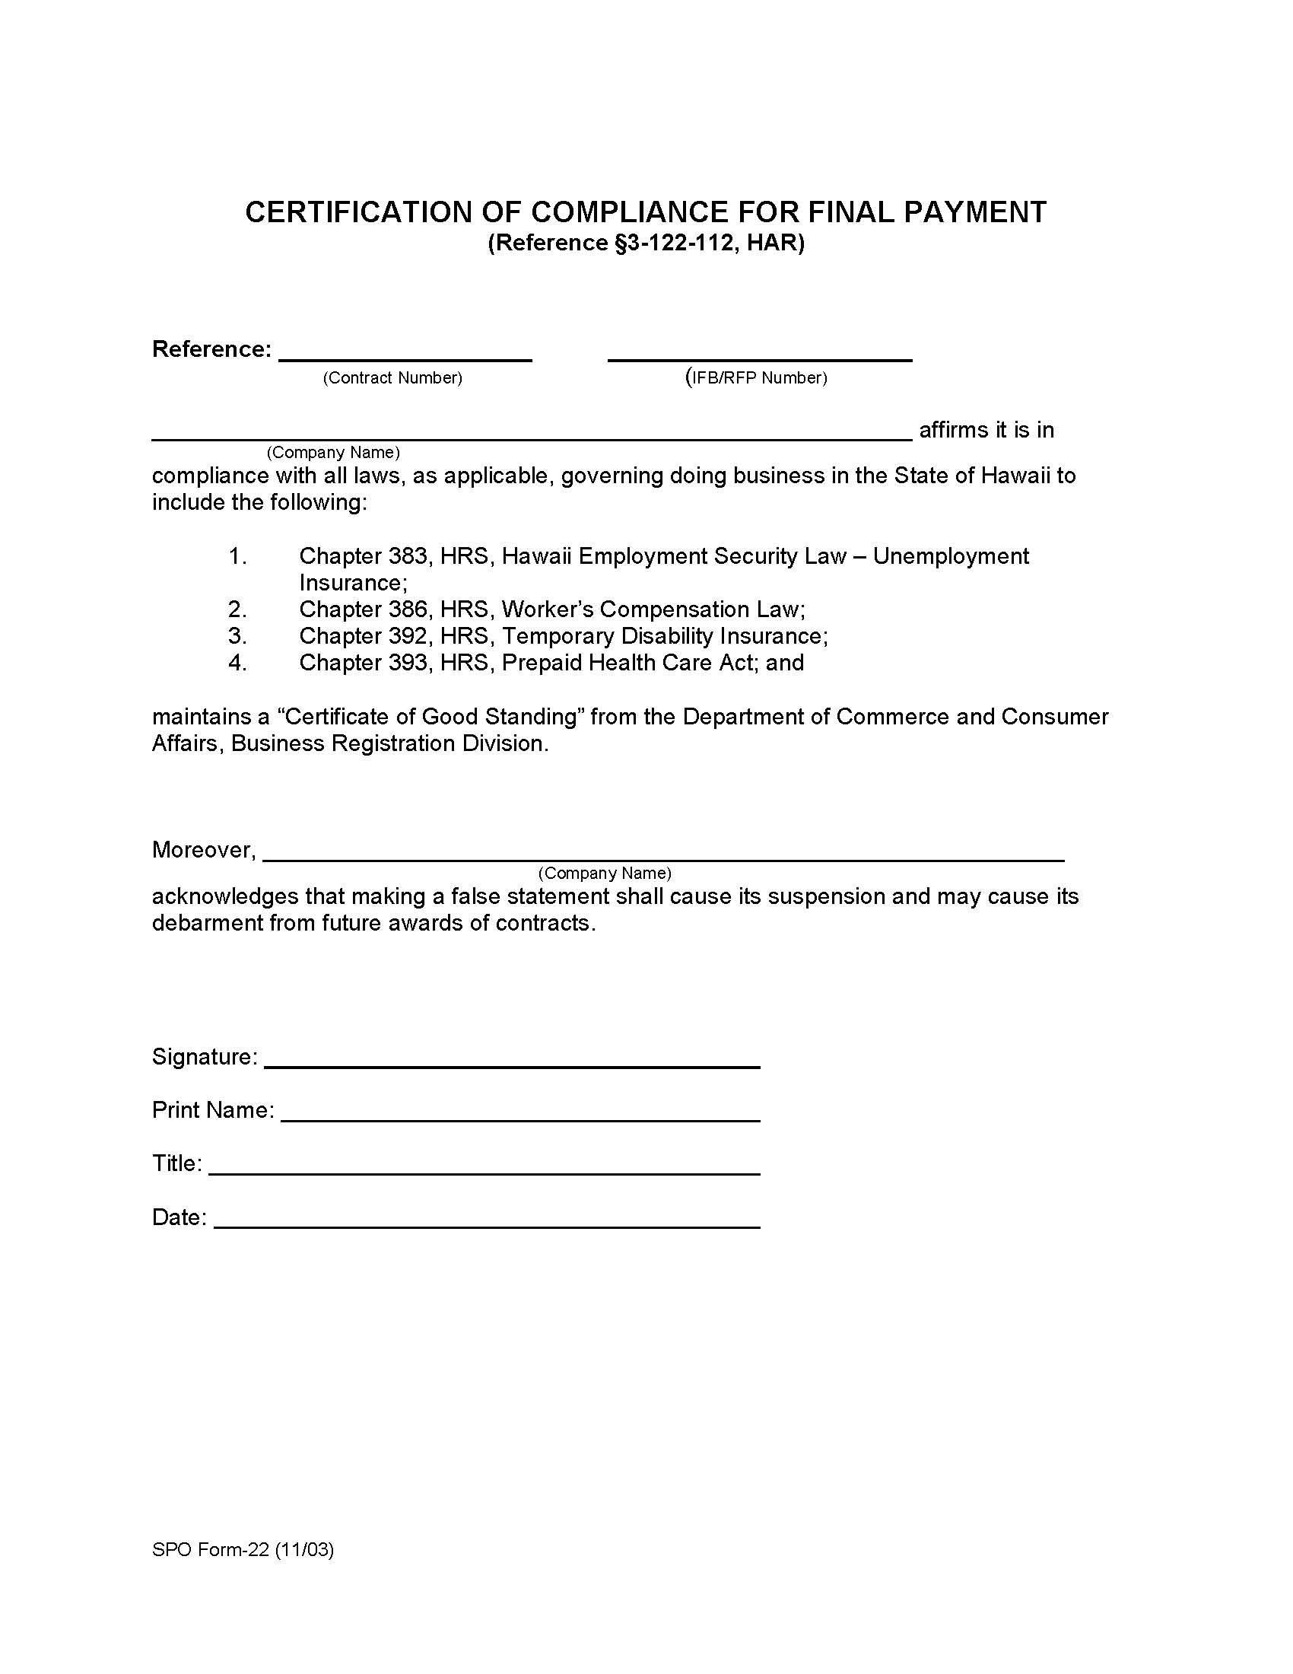

STATE OF HAWAII

NATURAL ENERGY LABORATORY OF HAWAII AUTHORITY
NELHA SECURITY SERVICES
SOLICITATION No. eIFB-26-03-NELHA
ATTACHMENT 4 – GENERAL CONDITIONS
AG-008

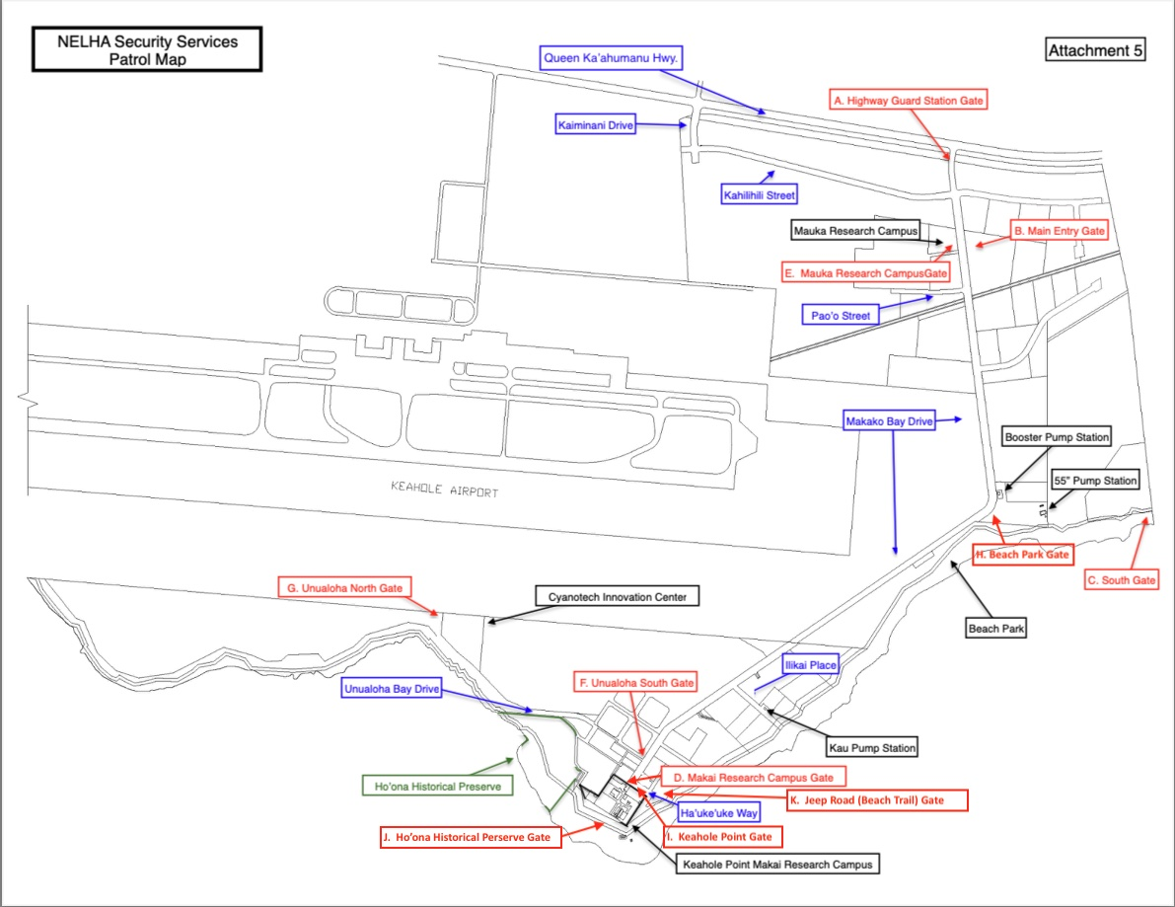

Attachment 6
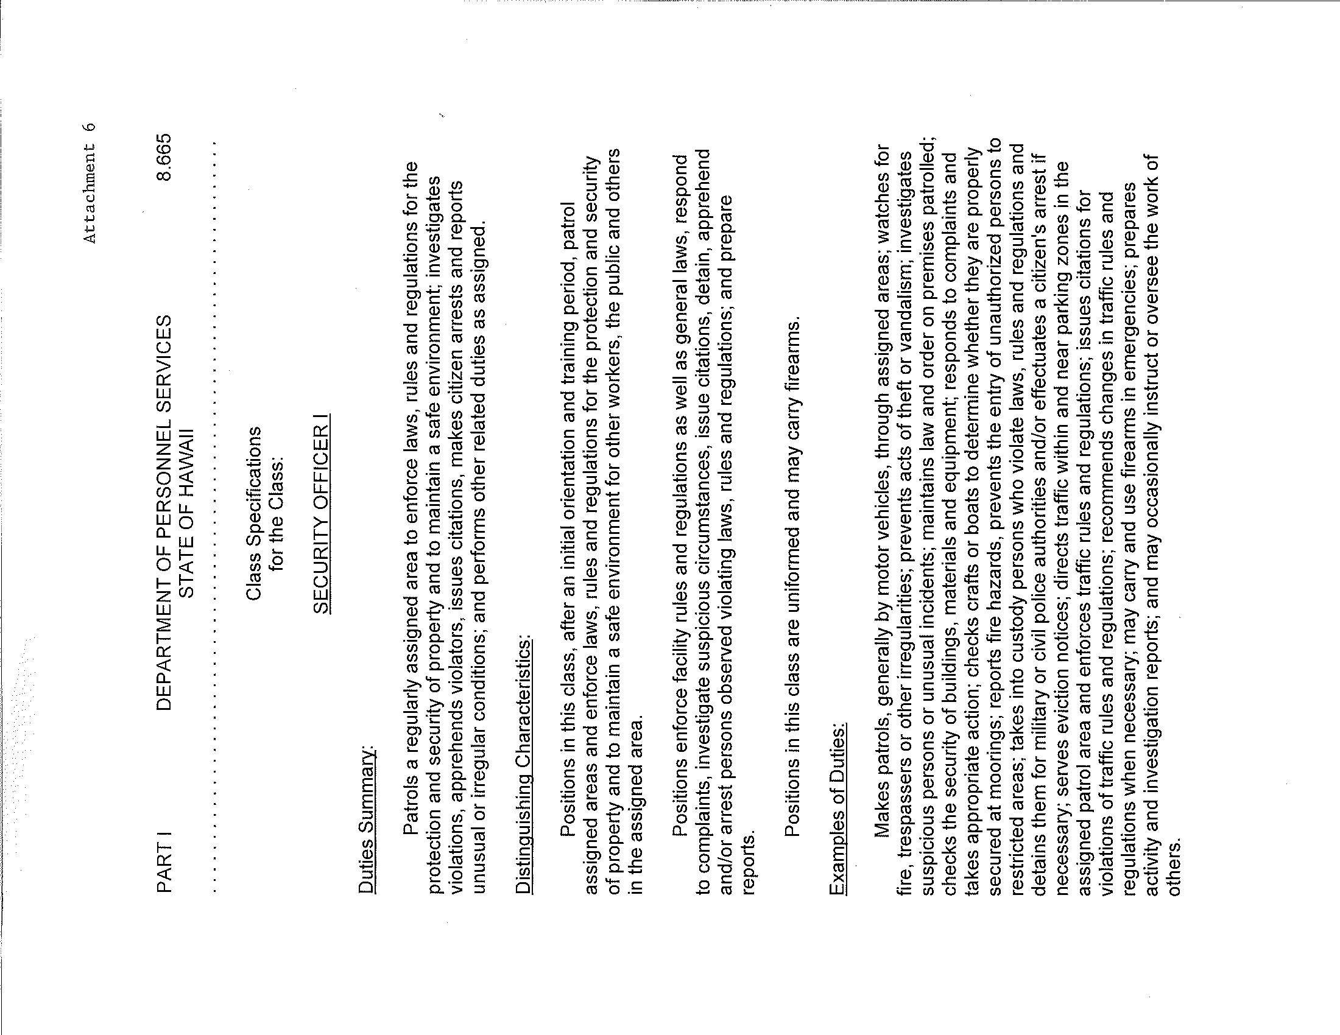
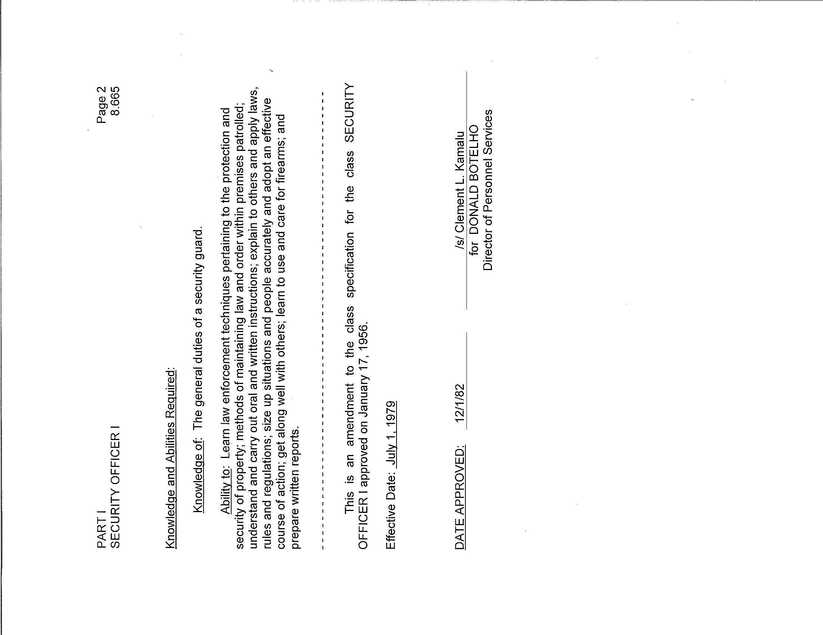
Attachment 7
WAGE CERTIFICATE
FOR SERVICE CONTRACTS
Subject: eIFB-26-03-NELHA
Title: NELHA Security Services
Pursuant to Section 103-55, Hawaii Revised Statutes (HRS), I hereby certify that if awarded the contract in excess of $25,000, the services to be performed will be performed under the following conditions:
- All applicable laws of the federal and state governments relating to workers' compensation, unemployment compensation, payment of wages, and safety will be fully complied with; and
- The services to be rendered shall be performed by employees paid at wages or salaries not less than the wages paid to public officers and employees for similar work, with the exception of professional, managerial, supervisory, and clerical personnel who are not covered by Section 103-55, HRS.
I understand that failure to comply with the above conditions during the period of the contract shall result in cancellation of the contract, unless such noncompliance is corrected within a reasonable period as determined by the procurement officer. Payment in the final settlement of the contract or the release of bonds, if applicable, or both shall not be made unless the procurement officer has determined that the noncompliance has been corrected; and
I further understand that all payments required by Federal and State laws to be made by employers for the benefit of their employees are to be paid in addition to the base wage required by section 103-55, HRS.
Bidder:
Signature:
Title:
Date:

Attachment 8

